Lab # 02



Submitted by:

Submitted by:

Name | Registration No.
Syeda Aima Abbas | FA24-BSE-010

Submitted to: Sir imran
Course: CSC462

DEPARTMENT OF COMPUTER SCIENCE
COMSATS UNIVERSITY ISLAMABAD, ISLAMABAD CAMPUS

Lab Task 1:

Code:

list1 =input("Enter values for the first list separated by spaces: ").split() list2 = input("Enter values for the second list separated by spaces: ").split()

merged_list = list1 + list2

sorted_list = sorted(merged_list)

print("Sorted merged list:", sorted_list)

Output:
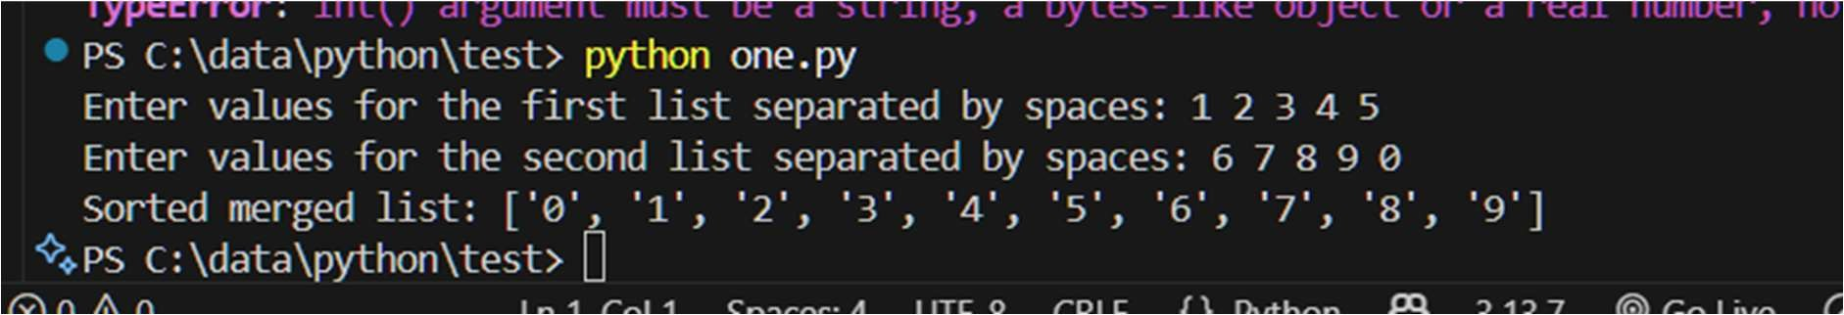

Lab Task 2:

Code:
list1 = input("Enter values for the first list separated by spaces: ").split() list2 = input("Enter values for the second list separated by spaces: ").split() list1 = [int(x) for x in list1] list2 = [int(x) for x in list2]

merged_list = list1 + list2 sorted_list = sorted(merged_list)

smallest = min(sorted_list) largest = max(sorted_list)

print("Sorted merged list:", sorted_list) print("Smallest element:", smallest) print("Largest element:", largest)

Output:
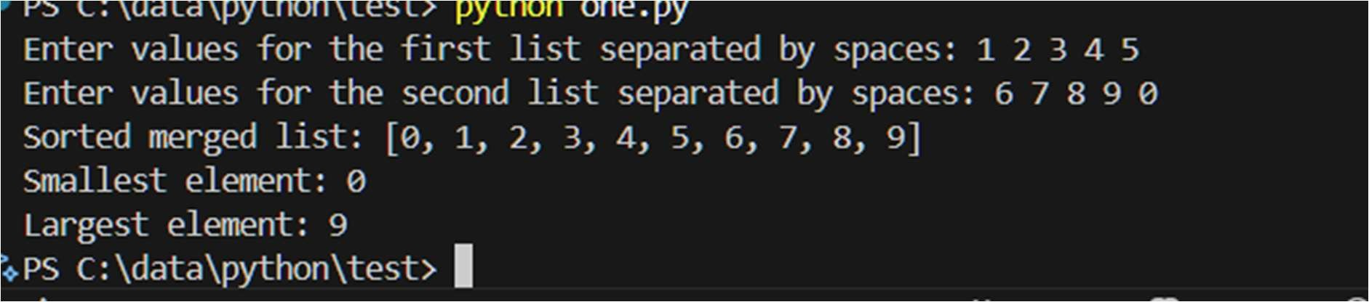

Lab Task 3:
Code:
# Numerical derivative of sin(x) using finite differences from math import *

def numerical_derivative_sin(h):
x_values = [] approx_deriv = [] exact_deriv = [] sin_values = [] cos_values = [] x = -pi while x <= pi: x_values.append(x) sinx = sin(x) sinx_h = sin(x + h) deriv_approx = (sinx_h - sinx) / h cosx = cos(x) approx_deriv.append(deriv_approx) exact_deriv.append(cosx) sin_values.append(sinx) cos_values.append(cosx) x += 0.001 print(f"\nResults for h = {h}:")
print(f"{'x':>10} {'sin(x)':>12} {'Approx d/dx sin(x)':>20} {'cos(x)':>12} {'Error':>12}") for i in range(0, len(x_values), max(1, len(x_values)//10)):
err = abs(approx_deriv[i] - exact_deriv[i])
print(f"{x_values[i]:10.4f} {sin_values[i]:12.6f} {approx_deriv[i]:20.6f}
{cos_values[i]:12.6f} {err:12.6f}")
# Print average error avg_error = sum(abs(a - b) for a, b in zip(approx_deriv, exact_deriv)) / len(x_values) print(f"Average error for h = {h}: {avg_error:.6e}\n")

for h in [0.001, 0.01, 0.1]:
numerical_derivative_sin(h)
Output:
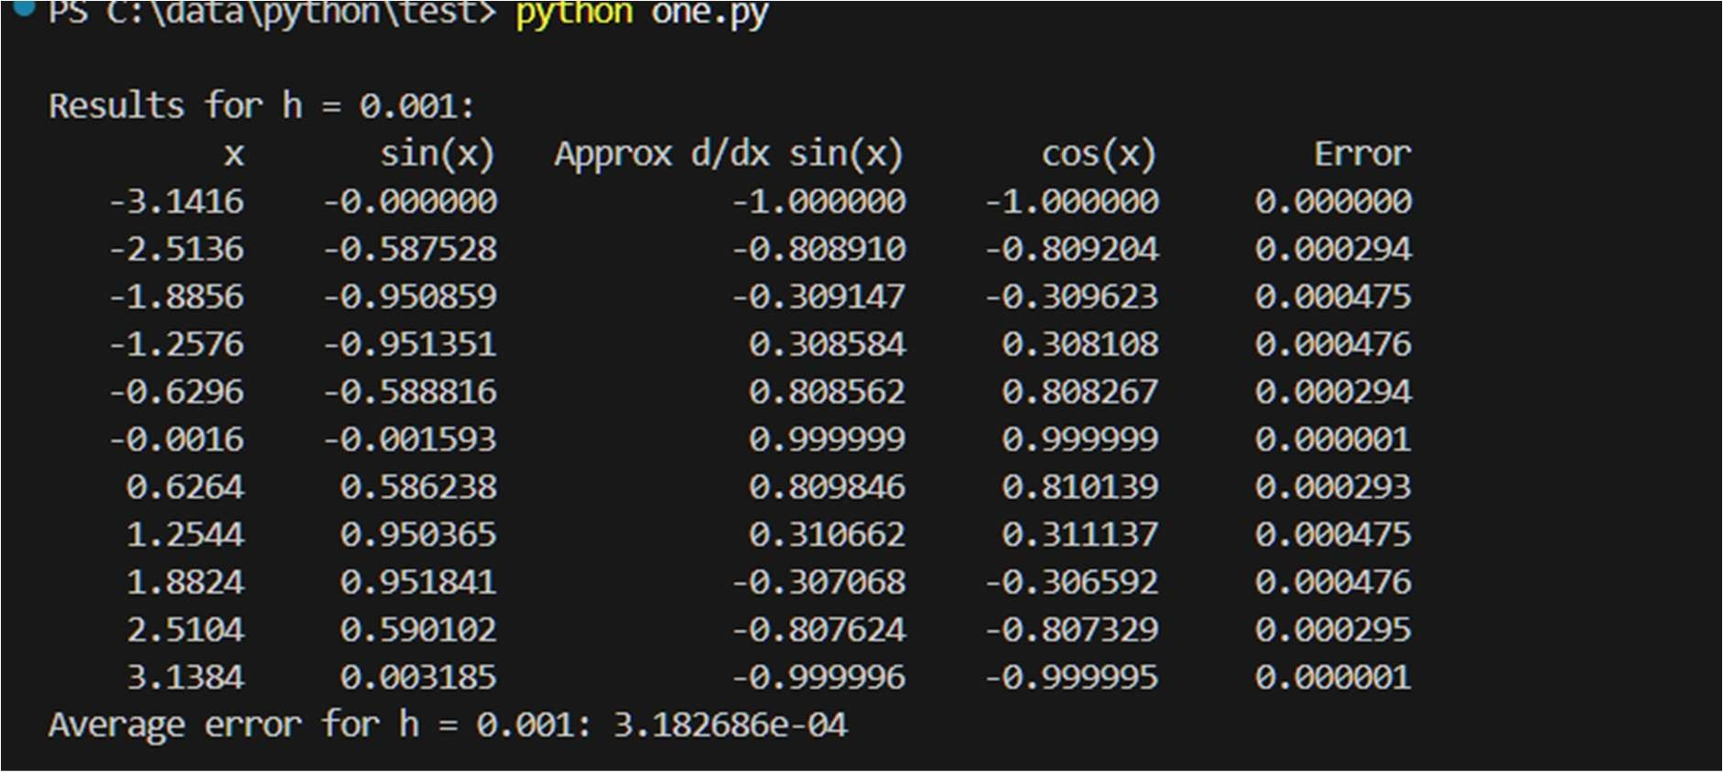

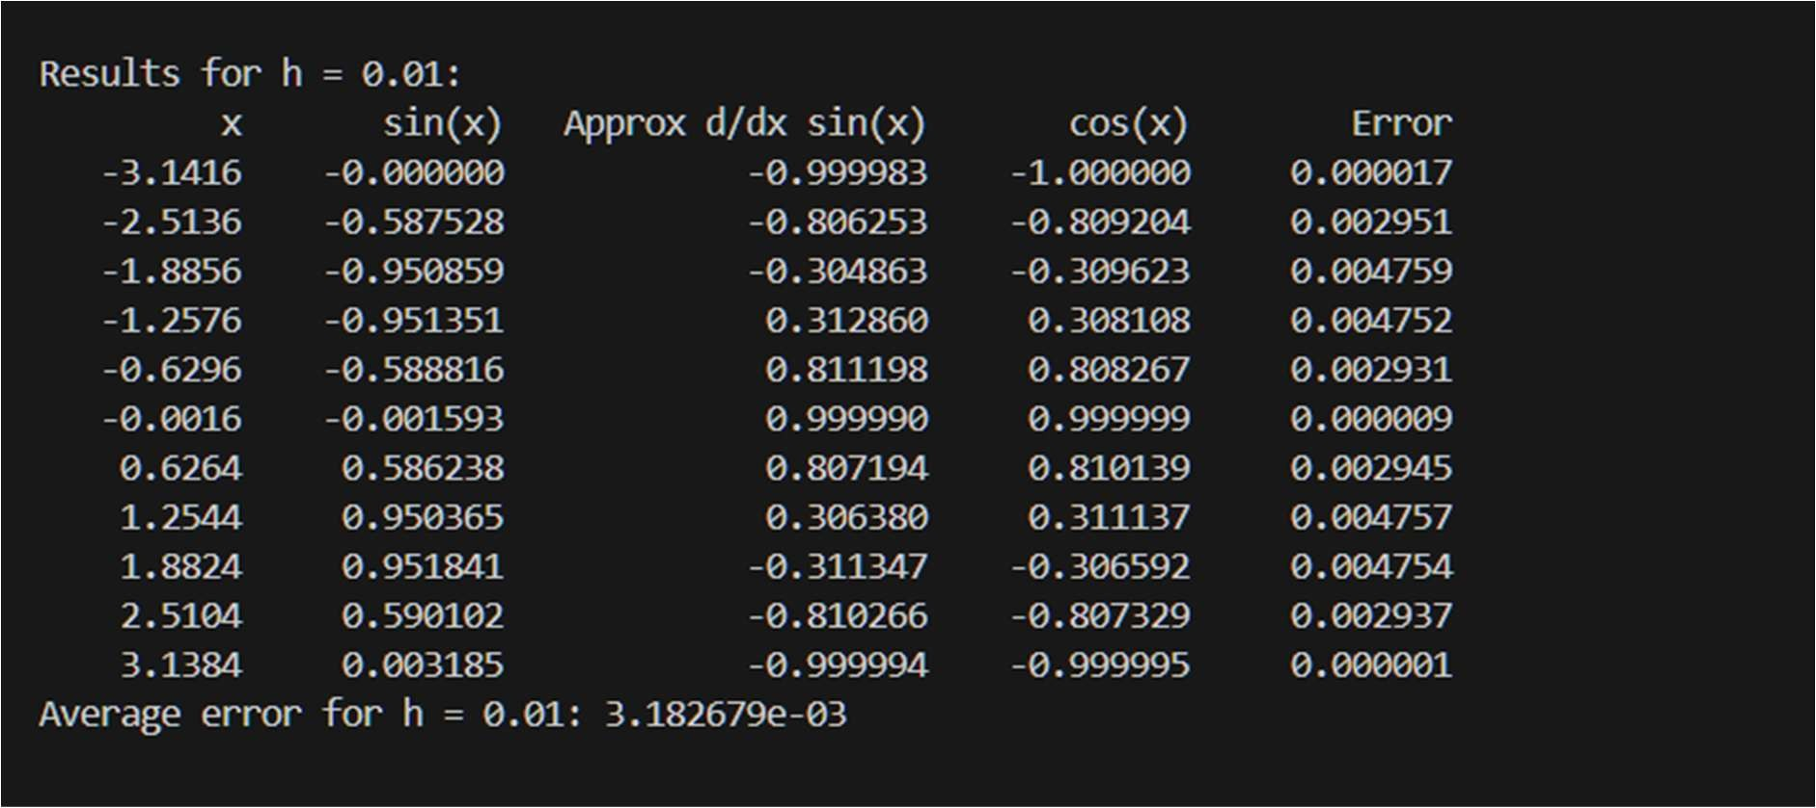
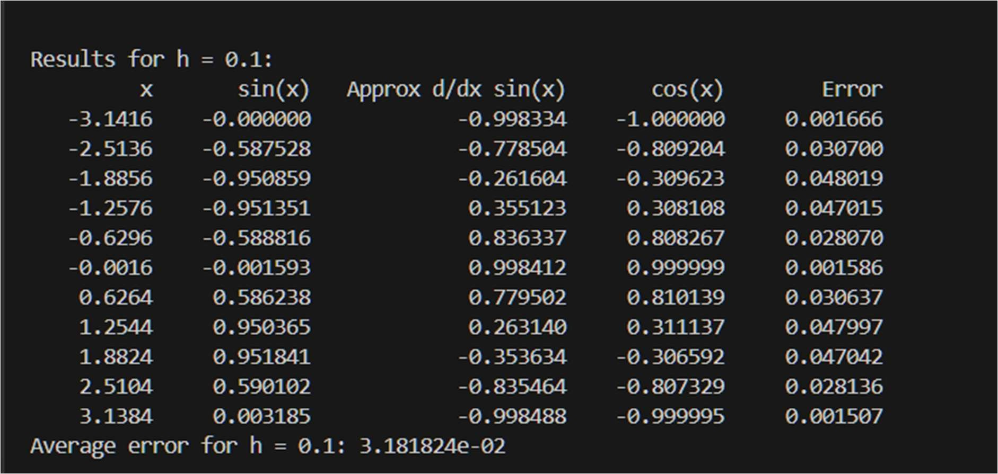
Lab Task 4:
Code:

# Lab Task 4: Birthday dictionary def birthday_dictionary():
birthdays = {
"Hashim": "03/14/1879",
"Ali": "01/17/1706",
"Khan": "12/10/1815"
}
print("Welcome to the birthday dictionary. We know the birthdays of:") for name in birthdays:
print(name)
name = input("\nWho's birthday do you want to look up?\n") if name in birthdays:
print(f"{name}'s birthday is {birthdays[name]}.") else:
print(f"Sorry, we don't have the birthday for {name}.")

birthday_dictionary()

Output:
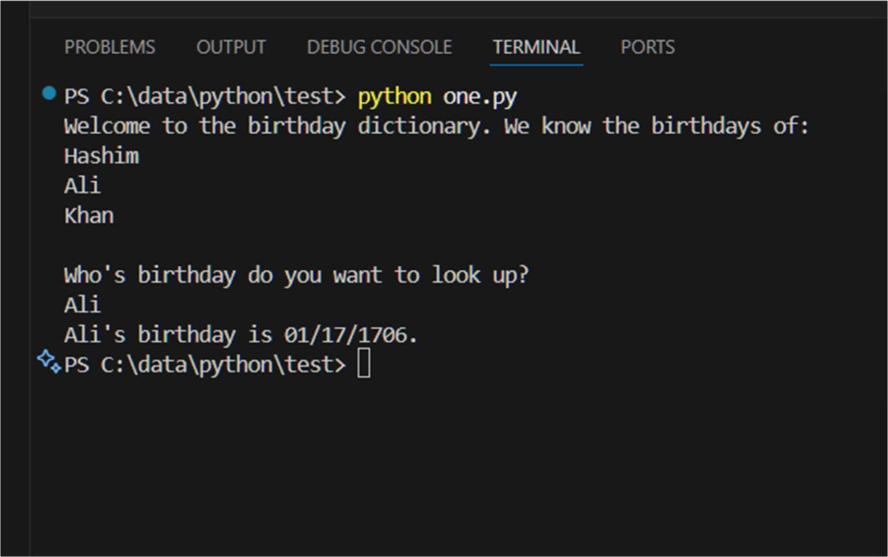

Lab task 5:
Code:

def extract_keys_from_dict():
sample_dict = { "name": "Kelly",
"age": 25,
"salary": 8000,
"city": "New york"
}
keys = ["name", "salary"] new_dict = {k: sample_dict[k] for k in keys} print(new_dict)

extract_keys_from_dict()

Output:
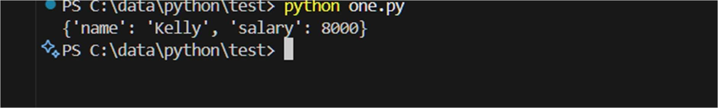

BFS LAB TASKS :
LAB TASK 1:
graph = {
'Arad': ['Zerind', 'Timisoara', 'Sibiu'],
'Zerind': ['Arad', 'Oradea'],
'Timisoara': ['Arad', 'Lugoj'],
'Sibiu': ['Arad', 'Oradea', 'Fagaras', 'Rimnicu Vilcea'],
'Oradea': ['Zerind', 'Sibiu'],
'Lugoj': ['Timisoara', 'Mehadia'],
'Mehadia': ['Lugoj', 'Drobeta'],
'Drobeta': ['Mehadia', 'Craiova'],
'Craiova': ['Drobeta', 'Rimnicu Vilcea', 'Pitesti'],
'Rimnicu Vilcea': ['Sibiu', 'Craiova', 'Pitesti'],
'Fagaras': ['Sibiu', 'Bucharest'],
'Pitesti': ['Rimnicu Vilcea', 'Craiova', 'Bucharest'],
'Bucharest': ['Fagaras', 'Pitesti']
}
def bfs_traversal(graph, start, goal):

opened = [start]
closed = []

while opened:

node = opened.pop(0)

if node == goal:
closed.append(node)
return "SUCCESS", closed
else:
closed.append(node)

opened = opened + [child for child in graph[node] if child not in opened and child not in closed]
return 'GOAL Not FOUND'

msg, bfsTraversal = bfs_traversal(graph,'Arad','Bucharest')
print(msg,"\nBFS Traversal = ", bfsTraversal)

OUTPUT:
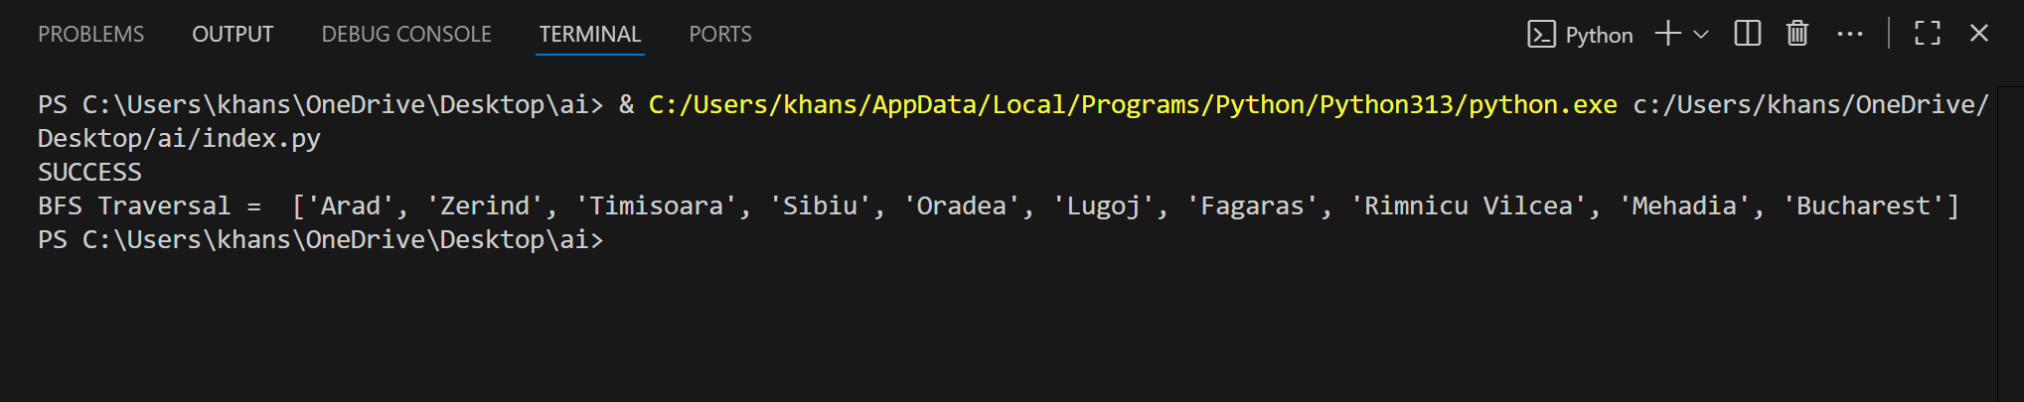
LAB TASK 2:
graph = {
'A': ['B', 'I'],
'B': ['A', 'C'],
'C': ['B', 'D'],
'D': ['C', 'E'],
'E': ['D', 'F'], # Goal is at E
'F': ['E', 'G'],
'G': ['F', 'H'],
'H': ['G', 'J'], # Connects to middle start branch
'I': ['A', 'J'],
'J': ['I', 'H', 'K'], # Start node
'K': ['J', 'L'],
'L': ['K', 'M'],
'M': ['L', 'N'],
'N': ['M', 'O'],
'O': ['N', 'P'],
'P': ['O', 'Q'],
'Q': ['P']
}

def bfs_traversal(graph, start, goal):

opened = [start]
closed = []

while opened:

node = opened.pop(0)

if node == goal:
closed.append(node)
return "SUCCESS", closed
else:
closed.append(node)

opened = opened + [child for child in graph[node] if child not in opened and child not in closed]
return 'GOAL Not FOUND'

msg, bfsTraversal = bfs_traversal(graph,'J','E')
print(msg,"\nBFS Traversal = ", bfsTraversal)

output:
